**Instruction of software burning**

Please cut off the AC&DC power before operation.

1. Connect programmer to IC

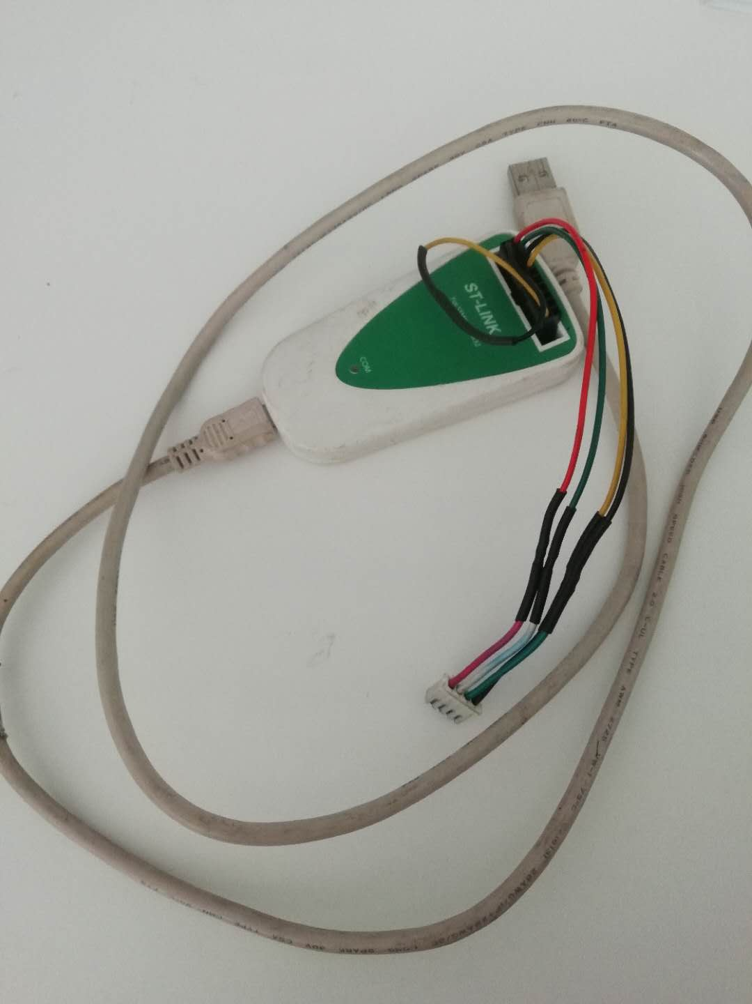

Port 1

Picture1 programmer

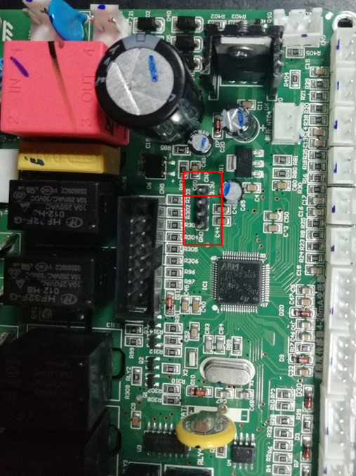

Port 2

Connect port 1 to port 2

Picture 2 board

Connect port 1 to port 2

5V will be shown here.

1. Connect programmer to the USB port of the computer.

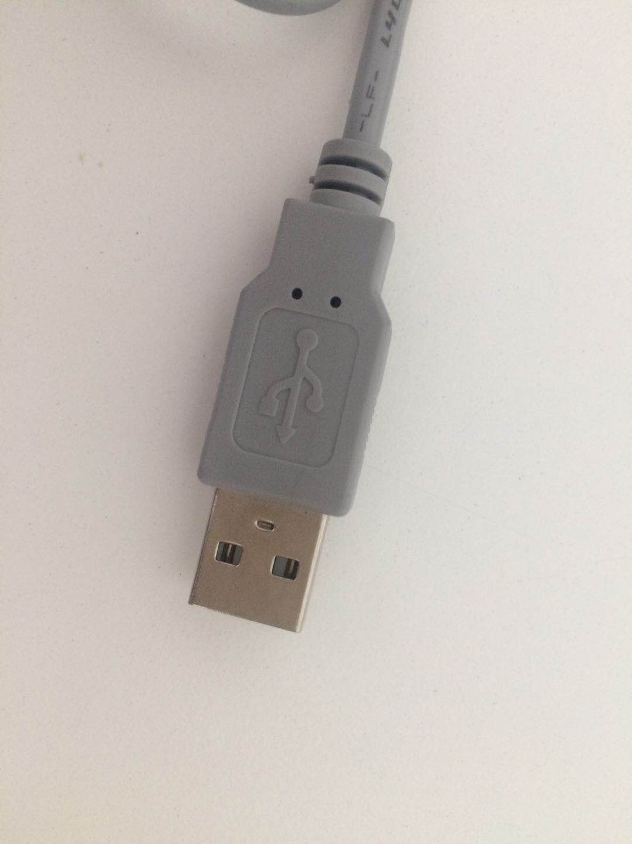

Connect the programmer port to the USB port of PC

Picture5

3. Open the software(ST Visual Programmer).

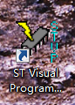

After opening the software, we can see the interface shown as the picture.

Double click to open the software

Picture6

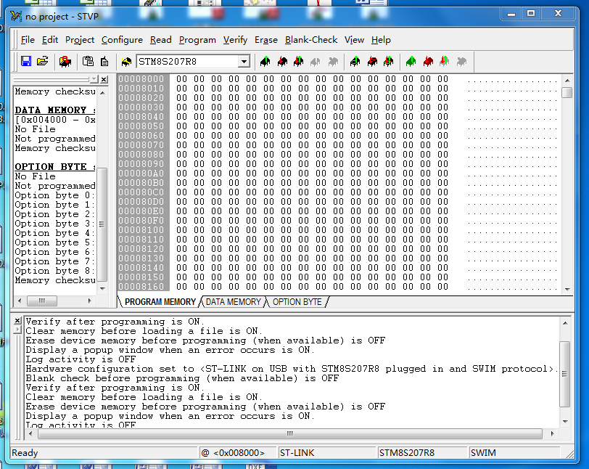

Picture7

4.Selecting the kind of the IC



Pop up the drop-down list. And then select “STM32F103x8”

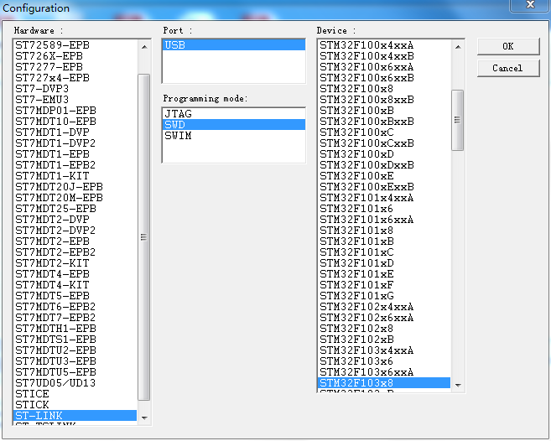

Picture8

5.Loading file

5.1 Loading program file



Click to load the program file

Picture9



And then open the files

Picture10

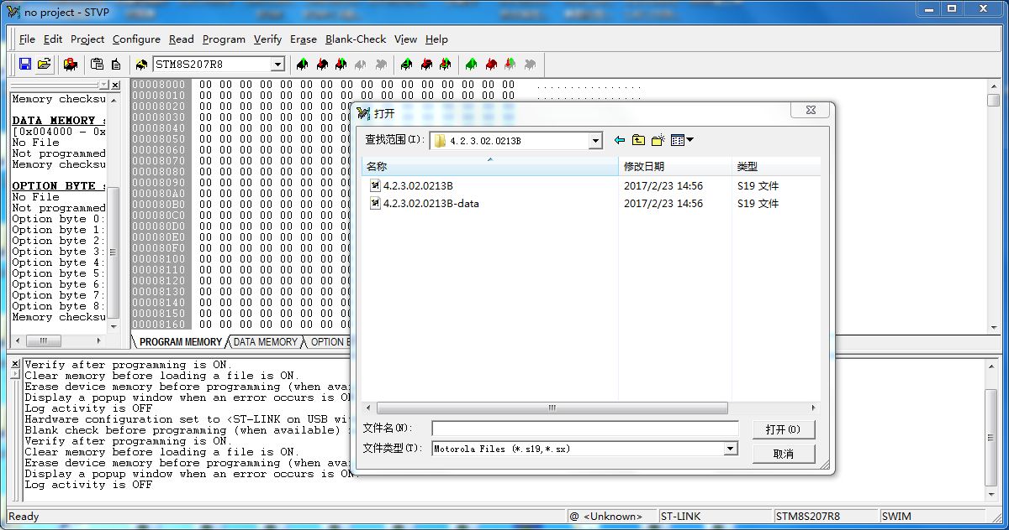

Find the correct file and double click

Picture11

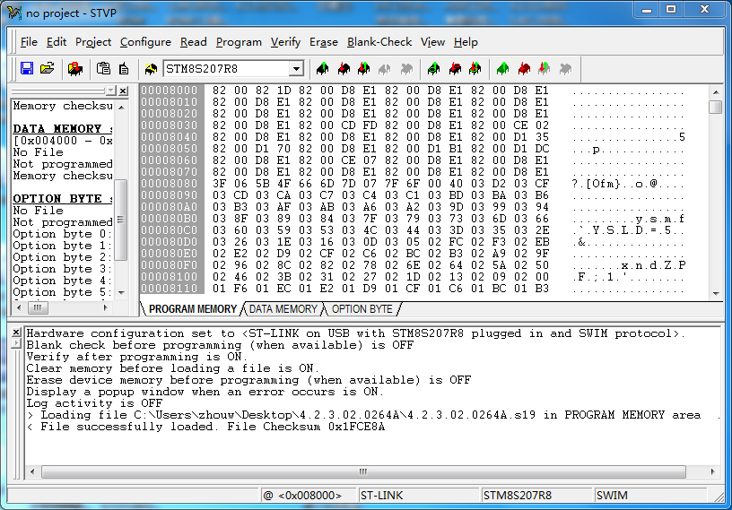

Load program file

Picture 12

Erase the old programme

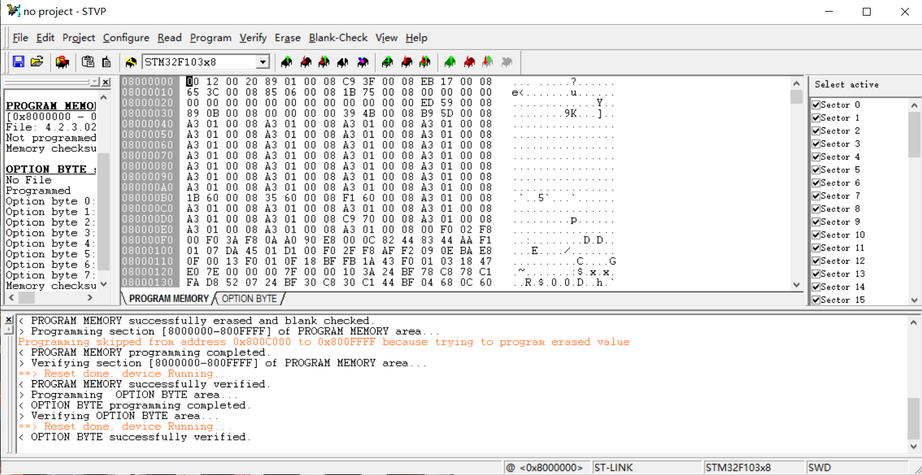



Load the programme to the borad